**CSC 1101 – Problem Solving and Programming Laboratory**

**Lab 13 – Omar Faruk**

**25 points – Due October 13, end of lab**

**a)** Save this document with your name and the lab assignment number somewhere in the file name.

**b)** Type/paste your answers into the document.

**c)** Submit this document to the Canvas item where you downloaded this document.

***Problem Title: Magic Number***

Write a C++ console application to find out if a number is a **special number** or not. A number is special if certain division operations have a sum greater than the number itself. First, use a validation loop to prompt for and get from the user integer N within the range 20-10,000. Then use a for loop to loop from 1 to N (loop N times). For each number in the range 1-N, check if it satisfies the compound condition:

Divisible by 3 and

Divisible by 5 and

Not divisible by 2 and

Not divisible by 4

For example, to check if i is divisible by 6, use condition:

i % 6 == 0

If the condition is true, i is divisible by 6. For each number in the range 1-N that satisfies the compound condition, add it to a running sum (set the sum to zero before the for loop). After the for loop, check if the sum is greater than N. If so, the number is special. If not, the number is not special.

Sample Input/Output will be helpful to write your code. Attach a different input/output for your submission.

**Sample Input/Output:**

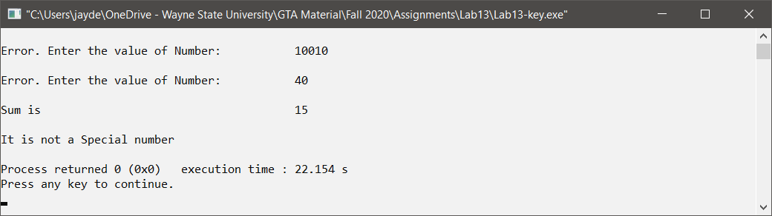

*[your program code here]\**

//==========================================================

//

// Title: Magic Number

// Course: CSC 1101

// Lab Number: Lab 13

// Author: Omar Faruk

// Date: 10/27/2020

// Description:

// Taking input from user then using validaton loop and for loop

// to determine the sum and if it is a special number.

//

//==========================================================

#include <cstdlib> // For several general-purpose functions

#include <fstream> // For file handling

#include <iomanip> // For formatted output

#include <iostream> // For cin, cout, and system

#include <string> // For string data type

using namespace std; // So "std::cout" may be abbreviated to "cout"

int main()

{

// Declare constants

const int COLMFT1 = 45;

const int COLMFT2 = 7;

// Declare variables

int user_input;

int sum = 0;

int i = 1;

// Show application header

cout << "Welcome to Magic Number!" << endl;

cout << "------------------------" << endl << endl;

// Print to screen w. validation and for loop

cout << setw(COLMFT1) << left << "Enter the value of a number: ";

cin >> setw(COLMFT2) >> right >> user_input;

while (user_input < 20 || user_input > 10000)

{

cout << setw(COLMFT1) << left << "\nError: Enter value again:";

cin >> setw(COLMFT2) >> right >> user_input;

}

for (i=1; i< user_input; i++)

{

if ( i % 3 == 0 && i % 5 == 0 && i % 2 != 0 && i % 4 != 0 )

{

sum = sum + i;

}

}

cout << setw(COLMFT1) << left << "\nSum is";

cout << setw(COLMFT2) << left << sum;

// Check number

if (sum > user_input)

cout << setw(COLMFT1) << endl << "\nCongratulations, it is a special number!" << endl;

else

{

cout << setw(COLMFT1) << endl << "\nIt is not special number!" << endl;

}

// Show application close

cout << "\nEnd of Magic Number" << endl;

}

*[your program output here]\*\**

